# On-Demand Services

Finding workers for simple home repairs like plumbing and electrical is expensive as well as complex. A web app idea that can tackle this problem is an on-demand services app. Consumers may access several home services using a single web app.

# Database design

This app can revolve around this simple design:

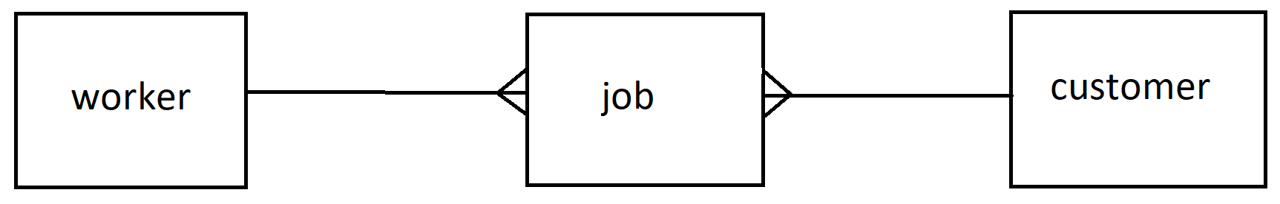

# worker

Create profiles for workers, including the services that they offer e.g. plumber. They will need to provide availability which can be expressed as slots in a calendar. These slots can be implemented as one ‘job’ each without a customer or time applied to it.

# customer

Create a log and profile for customers. Make a selection of a service, and a select a time. The time can show available times for workers that provide the selected job.

# job

When we make a selection for a worker, we can automatically create an appointment for a worker, which basically fills in the details for that ‘job’.

# Additional things to think about

Error handling

Testing

Documentation (User guide / walkthrough && readme)

# Alternatives

The same basic structure can be used to do a ‘doctor appointment booking system’ where a doctor is a ‘worker’ the patient is a ‘client’ and an appointment is a ‘job’.